# Kennesaw State University

College of Computing and Software Engineering

Department of Computer Science

CS 5070, Mathematical Structures for Computer Science, Section W01

Assignment #2

Amrit Singh, [asingh59@students.kennesaw.edu](mailto:asingh59@students.kennesaw.edu)

06/08/2025

## Problem Statement

Problem of this document is to solve the following problem set for assignment #2.

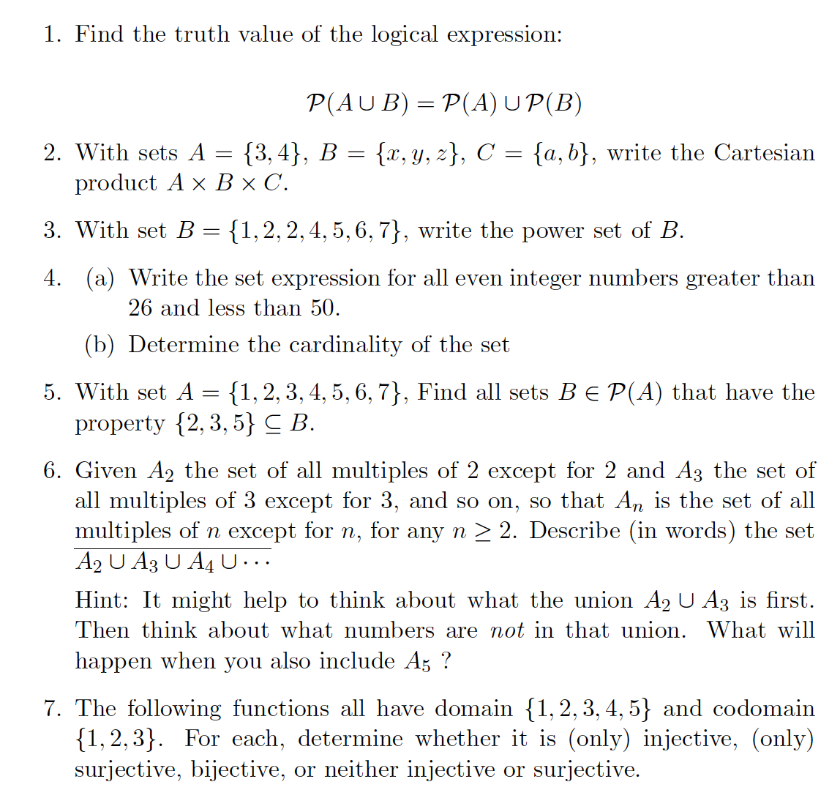

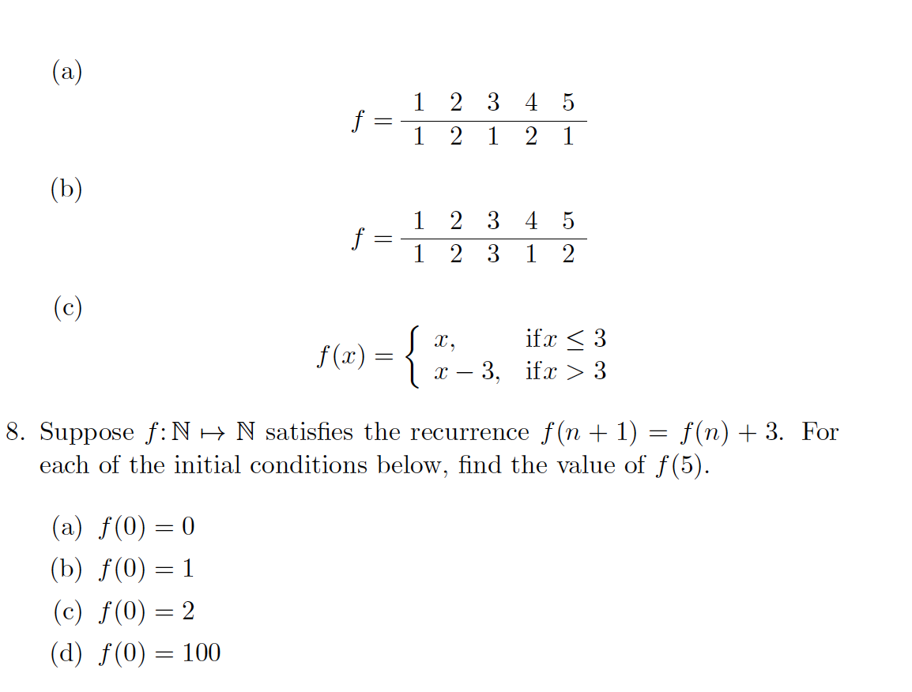

## Summary / Purpose

Purpose of this document is to provide solutions to the problem set outlined in the Problem Statement section.

## Solutions

1. Find the truth value of the logical expression:

$$P\left(A∪B\right)= P\left(A)∪ P(B\right)$$

The power set of a set is the collection of all subsets, including the empty set ∅. Suppose we have the following two sets:

A = {1, 2} and B = {3}

The power set $P\left(A∪B\right)$ would be $P\left(\left\{1, 2, 3\right\}\right)$ which is:

$P\left(A∪B\right)=$ {∅, {1}, {2}, {3}, {1,2}, {1,3}, {2,3}, {1, 2, 3}}

The power set $P\left(A\right)$ would be $P\left(\left\{1, 2\right\}\right)$ which is:

$P\left(A\right)=$ {∅, {1},{2}, {1,2}}

The power set $P\left(B\right)$ would be $P\left(\left\{3\right\}\right)$ which is:

$P\left(B\right)=$ {∅, {3}}

This would make $P\left(A)∪P(B\right)$ equal to {∅, {1},{2}, {1,2}} $∪$ {{}, {3}}, which is:

$P\left(A)∪P(B\right)$ = {∅, {1}, {2}, {3}, {1,2}}

Therefore, we have deduced that $$P\left(A∪B\right)≠ P\left(A)∪ P(B\right)$$

Since

{∅, {1}, {2}, {3}, {1,2}, {1,3}, {2,3}, {1, 2, 3}} $≠$ {{}, {1}, {2}, {3}, {1,2}}

1. With sets *A* = {3, 4}, *B* = {x, y, z}, *C* = {a, b}, write the Cartesian Product *A* × *B* × *C*

The Cartesian Product of *A* × *B* × *C* the set of ordered pairs (*x*, *y*, *z*) where *x* is an element of *A*, *y* is an element of *B*, and *z* is an element of *C* where:

*A* × *B* × *C* = $\left\{\left(x, y,z\right) :x∈A∧y∈B∧z∈C \right\}$

Let *A* = {3, 4}, *B* = {x, y, z}, and *C* = {a, b},

*A* × *B* × *C* =

{{3,x,a}, {3,x,b}, {3,y,a}, {3,y,b}, {3,z,a}, {3,z,b},

{4,x,a}, {4,x,b}, {4,y,a}, {4,y,b}, {4,z,a}, {4,z,b}}

1. With set *B* = {1, 2, 2, 4, 5, 6, 7}, write the power set of *B*.

The power set of a set is the collection of all subsets, including the empty set ∅.

The set *B* = {1, 2, 2, 4, 5, 6, 7} is equal to {1, 2, 4, 5, 6, 7} since the 2’s are duplicates. The power set of *B* is then:

$P(B)=$

{∅, {1}, {2}, {4}, {5}, {6}, {7}, {1,2}, {1,4}, {1,5},

{1,6}, {1,7}, {2,4}, {2,5}, {2,6}, {2,7}, {4,5}, {4,6}, {4,7}, {5,6},

{5,7}, {6,7}, {1,2,4}, {1,2,5}, {1,2,6}, {1,2,7}, {1,4,5}, {1,4,6}, {1,4,7}, {1,5,6},

{1,5,7}, {1,6,7}, {2,4,5}, {2,4,6}, {2,4,7}, {2,5,6}, {2,5,7}, {2,6,7}, {4,5,6}, {4,5,7},

{4,6,7}, {5,6,7}, {1,2,4,5}, {1,2,4,6}, {1,2,4,7}, {1,2,5,6}, {1,2,5,7}, {1,2,6,7}, {1,4,5,6}, {1,4,5,7},

{1,4,6,7}, {1,5,6,7}, {2,4,5,6}, {2,4,5,7}, {2,4,6,7}, {2,5,6,7}, {4,5,6,7}, {1,2,4,5,6}, {1,2,4,5,7}, {1,2,4,6,7},

{1,2,5,6,7}, {1,4,5,6,7}, {2,4,5,6,7}, {1,2,3,4,5,6,7}}

= (6 x 10 + 4) = 64 items

1. (a) Write the set expression for all even integer numbers greater than 26 and less than 50

$$A=\left\{x∈\left\{26, 27, 28…48, 49, 50\right\}:∃n∈N (\left(x = 2n\right)∧(x>26)∧(x<50 ) \right\}$$

$$A=\{28, 30, 32, 34, 36, 38, 40, 42, 44, 46, 48\}$$

(b) Determine the cardinality of the set.

The cardinality is the size of the set, and in this case |*A*| = 11.

1. With set *A* = {1, 2, 3, 4, 5, 6, 7}, find all sets *B* ∈ 𝒫(A) that have the property {2, 3, 5} ⊆ *B.*

The power set of *A*, 𝒫(A), has 128 sets. We’re trying to find all sets where *B* is an element of 𝒫(A) with a property such that the set {2, 3, 5} must be a subset (inclusive) of *B*. This means that the elements 2, 3, 5 must be in the set. Any additional elements of 1,4, 6, 7 can be in the set, i.e {2, 3, 5} ∪ {1, 4, 6, 7} or {2, 3, 5} ∪ {4, 6, 7} etc.

The sets *B* ∈ 𝒫(A) that have the property {2, 3, 5} ⊆ *B* are:

∅ ∪ {2, 3, 5} = {∅, 2, 3, 5}

{1} ∪ {2, 3, 5} = {1, 2, 3, 5}

{4} ∪ {2, 3, 5} = {2, 3, 4, 5}

{6} ∪ {2, 3, 5} = {6, 2, 3, 5}

{7} ∪ {2, 3, 5} = {7, 2, 3, 5}

{1, 4} ∪ {2, 3, 5} = {1, 4, 2, 3, 5}

{1, 6} ∪ {2, 3, 5} = {1, 6, 2, 3, 5}

{1, 7} ∪ {2, 3, 5} = {1, 7, 2, 3, 5}

{4, 6} ∪ {2, 3, 5} = {4, 6, 2, 3, 5}

{4, 7} ∪ {2, 3, 5} = {4, 7, 2, 3, 5}

{6, 7} ∪ {2, 3, 5} = {6, 7, 2, 3, 5}

{1, 4, 6} ∪ {2, 3, 5} = {1, 4, 6, 2, 3, 5}

{1, 4, 7} ∪ {2, 3, 5} = {1, 4, 7, 2, 3, 5}

{1, 6, 7} ∪ {2, 3, 5} = {1, 6, 7, 2, 3, 5}

{4, 6, 7} ∪ {2, 3, 5} = {4, 6, 7, 2, 3, 5}

{1, 4, 6, 7} ∪ {2, 3, 5} = {1, 4, 6, 7, 2, 3, 5}

1. Given A2 the set of all multiples of 2 except for 2 and A3 the set of all multiples of 3 except for 3, and so on, so that An is the set of all multiples of n except for n, for any n  >= 2. Describe (in words) the set A2 ∪ A3 ∪ A4 ∪ …

Hint: It might help to think about what the union A2 ∪ A3 is first, then think about what numbers are not in that union. What will happen when you also include A5?

For n >=2 and where m ∈ N: m ≠ n

A2 = {4, 6, 8, 10, 12, 14, 16, 18, 20, 22= …., 2m }

A3 = {6, 9, 12, 15, 18, 21, 24 …., 3m }

A4 = {8, 12, 16, 20, 24, 28, …., 4m }

A5 = {10, 15, 20, 25, 30, 35, 40, 45, …, 5m}

….

An = {n+n, n+2n, n+3n + n +4n, …., n*m} = {2n, 3n, 4n, 5n, …, n*m }

A2 ∪ A3 = {4, 6, 8, 9, 10, 12, 14, 15, 16, 18, 20, 21, 22, 24 ….. 2m, 3m}

A2 ∪ A3 ∪ A4 = {4, 6, 8, 9, 10, 12, 14, 15, 16, 18, 20, 21, 22, 24 ….. 2m, 3m, 4m}

A2 ∪ A3 ∪ A4 ∪ A5 = {4, 6, 8, 9, 10, 12, 14, 15, 16, 18, 20, 21, 22, 24 ….. 2m, 3m, 4m, 5m}

A2 ∪ A3 ∪ A4 ∪ A5 …∪ An {4, 6, 8, 9, 10, 12, 14, 15, 16, 18, 20, 21, 22, 24 ..., 3m, 4m, 5m, n*m}

The set of A2 ∪ A3 ∪ A4 ∪ A5 …∪ An , for n >=2 of all multiple of n except for n seems to include all numbers that are not prime ({1, 3, 5, 7, 11, 13, …}. These numbers are divisible by one other number other than 1 and itself. These are known as composite numbers. Therefore this set describes the set of all compositive numbers.

1. The following functions all of domain {1, 2, 3, 4, 5} and codomain {1, 2, 3}. For each, determine whether it is (only) injective, (only) surjective, bijective, or neither injective or surjective.

Injective means that each element of the codomain is the image of at most one element of the domain, aka one-to-one.

Subjective means that everything in the codomain is in the range, or outputs, aka onto.

Bijective means both, one-to-one and onto.

* 1. + 1, 3, 5 1
     + 2, 4 $→$ 2

The inputs 1, 3, and 5 map to 1 and the inputs 2 and 4 map to 2. No input of the domain maps to 3 of the codomain. This means that we can say that this function is not one-to-one nor onto, hence this is neither injective or surjective.

* 1. + 1, 4 1
     + 2, 5 2
     + 3 $→$ 3

The inputs 1 and 4 map to 1, 2 and 5 map to 2, and 3 maps to 3. All of the outputs of the codomain, aka the range, are mapped. Multiple inputs are mapped to the same output. This means we can say that this function is not one-to-one, but it is onto, hence this function is surjective.

* + - 1, 4 $→1$
    - 2, 5 $→$ 2
    - 3 $→$ 3

The inputs 1 and 4 map to 1, 2 and 5 map to 2, and 3 maps to 3. All of the outputs of the codomain, aka the range, are mapped. Multiple inputs are mapped to the same output. This means we can say that this function is not one-to-one, but it is onto, hence this function is surjective.

1. Suppose $f: N→ N$ satisfies the reoccurrence $f\left(n+1\right)=f\left(n\right)+3$. For each of the initial conditions below, find the value of $f\left(5\right)$.

$f\left(0\right)=0$

$$n=0=>f\left(0+1\right)=f\left(1\right)=f\left(0\right)+3=0+3=3$$

$$n=1=>f\left(1+1\right)=f\left(2\right)=f\left(1\right)+3=3+3=6$$

$$n=2=>f\left(2+1\right)=f\left(3\right)=f\left(2\right)+3=6+3=9$$

$$n=3=>f\left(3+1\right)=f\left(4\right)=f\left(3\right)+3=9+3=12$$

$$n=4=>f\left(4+1\right)=f\left(5\right)=f\left(4\right)+3=12+3=15$$

Thus, f(5) = 15 if f(0) = 0

$f\left(0\right)=1$

$$n=0=>f\left(0+1\right)=f\left(1\right)=f\left(0\right)+3=1+3=4$$

$$n=1=>f\left(1+1\right)=f\left(2\right)=f\left(1\right)+3=4+3=7$$

$$n=2=>f\left(2+1\right)=f\left(3\right)=f\left(2\right)+3=7+3=10$$

$$n=3=>f\left(3+1\right)=f\left(4\right)=f\left(3\right)+3=10+3=13$$

$$n=4=>f\left(4+1\right)=f\left(5\right)=f\left(4\right)+3=13+3=16$$

Thus, f(5) = 16 if f(0) = 1

$f\left(0\right)=2$

$$n=0=>f\left(0+1\right)=f\left(1\right)=f\left(0\right)+3=2+3=5$$

$$n=1=>f\left(1+1\right)=f\left(2\right)=f\left(1\right)+3=5+3=8$$

$$n=2=>f\left(2+1\right)=f\left(3\right)=f\left(2\right)+3=8+3=11$$

$$n=3=>f\left(3+1\right)=f\left(4\right)=f\left(3\right)+3=11+3=14$$

$$n=4=>f\left(4+1\right)=f\left(5\right)=f\left(4\right)+3=14+3=17$$

Thus, f(5) = 17 if f(0) = 2



$f\left(0\right)=100$ $$n=0=>f\left(0+1\right)=f\left(1\right)=f\left(0\right)+3=100+3=103$$

$$n=1=>f\left(1+1\right)=f\left(2\right)=f\left(1\right)+3=103+3=106$$

$$n=2=>f\left(2+1\right)=f\left(3\right)=f\left(2\right)+3=106+3=109$$

$$n=3=>f\left(3+1\right)=f\left(4\right)=f\left(3\right)+3=109+3=112$$

$$n=4=>f\left(4+1\right)=f\left(5\right)=f\left(4\right)+3=112+3=115$$

Thus, f(5) = 115 if f(0) = 100

## References

[1] Garrido, J. (2021, August 14). *CS5070 Mathematical Structures for Computer Science - Notes 1* [Slide show; Powerpoint]. D2L. https://kennesaw.view.usg.edu/d2l/le/content/3550928/viewContent/55786708/View?ou=3550928

[2] Garrido, J. (2022, May). *CS5070 Mathematical Structures for Computer Science - Notes 2* [Slide show; Powerpoint]. D2L. https://kennesaw.view.usg.edu/d2l/le/content/3550928/viewContent/55786709/View?ou=3550928

[3] Kennesaw State University, College of Computing and Software Engineering, Department of Computer Science, Mathematical Structures for Computer Science. (n.d.). CS5070 Assignment 2. In *https://kennesaw.view.usg.edu/d2l/le/dropbox/3550928/3805267/DownloadAttachment?fid=184379317*.

[4] Levin, O. (2016). *Discrete mathematics: An Open Introduction*.